Department for Environment, Food and Rural Affairs  Scottish Government  Welsh Government | 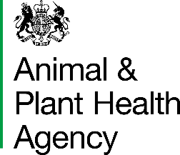
Request for APHA Veterinarian Countersignature of an Export Health Certificate

Please complete and submit the enclosed document to the appropriate team in the Centre for International Trade – Carlisle (CITC) to arrange for an APHA Veterinarian Countersignature of an Export Health Certificate (EHC).
Countersignatures of EHCs will only routinely be completed by an APHA Veterinarian at an APHA office during normal opening hours and not out-of-hours, over weekends or bank holidays.
Proposed date of countersignature:
Proposed time of countersignature:
Countersigning office/area:
Name of Exporter/Agent (if applicable):
Name of certifying Official Veterinarian (OV):
Name of horse(s) (if applicable):
EHC Online Case Reference Number (for EHC Online applications only and if known at time of application):
Serial number(s) of EHC (if known):
EHC number(s) (if known):
Name: |  | Date:
Email: |  | Telephone number:
Please submit your request to: processingteam@apha.gov.uk

DATA PROTECTION
For information on how we handle personal data please go to www.gov.uk and search Animal and Plant Health Agency Personal Information Charter.

APHA is an Executive Agency of the Department for Environment, Food and Rural Affairs and also works on behalf of the Scottish Government, Welsh Government and Food Standards Agency to safeguard animal and plant health for the benefit of people, the environment and the economy.

