Department for Environment, Food and Rural Affairs  Scottish Government  Welsh Government | 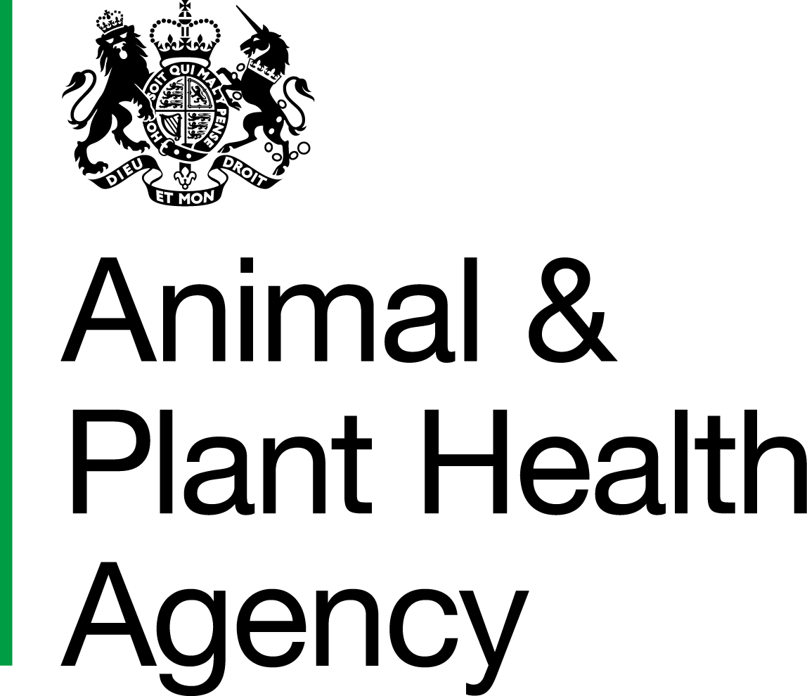
Notification of APHA Visits to (non-veterinary) Delivery Partners

The purpose of this form is to notify the relevant payment agencies of the date and time of all herd TB tests
to enable them to combine any Cattle Identification Inspection (CII) visits where appropriate.
OV/APHA office details
Name |  |  |  |  |  | Contact Name
Address |  |  |  |  |  | Telephone No.
 |  |  |  |  |  | Email address
 | Postcode |  |  |  |  | Fax number
Visit details |  |  |  |  |  | (Please complete a new sheet if further lines are required).
CPH |  | Name of Owner |  | Location of Test | Type of Test | Date and Time  of commencement |  | Date and Time  of reading | Name of OV or APHA tester | No. of animals to be tested  (if not known enter n/k)

Please email/fax visit details to the relevant Paying Agency to coordinate Cattle Identification Inspections where appropriate.  Paying Agencies require at least seven working days notice of the test date to co-ordinate the visit. | England | CII.TB.Admin@rpa.gsi.gov.uk | Fax: 01454 870060 | Tel: 01454 870049
 | Scotland (RPID) | LVInotifications@scotland.gsi.gov.uk | Fax: 0845 155 3367 | N/A
 | Wales | capm.inspectorate@wales.gsi.gov.uk | Fax: 01597 828304 | Tel: 01597 828323 Tel: 01597 828356

DATA PROTECTION
For information on how we handle personal data please go to www.gov.uk and search Animal and Plant Health Agency Personal Information Charter.

APHA is an Executive Agency of the Department for Environment, Food and Rural Affairs and also works on behalf of the Scottish Government, Welsh Government and Food Standards Agency to safeguard animal and plant health for the benefit of people, the environment and the economy.

